

Lunch items:

* The Burger $8.95
  + 8oz Grass Fed Beef Patty, Red Onion, House Made Aioli
* Signature Cheeseburger $9.95
  + 2 Quarter Pound Grass Fed Beef Patties, Melted Cheddar Cheese, House Made Garlic Aioli
* Summertime Brat $7.95
  + Pork Bratwurst seasoned with traditional German flavors, house made bun, Mustard

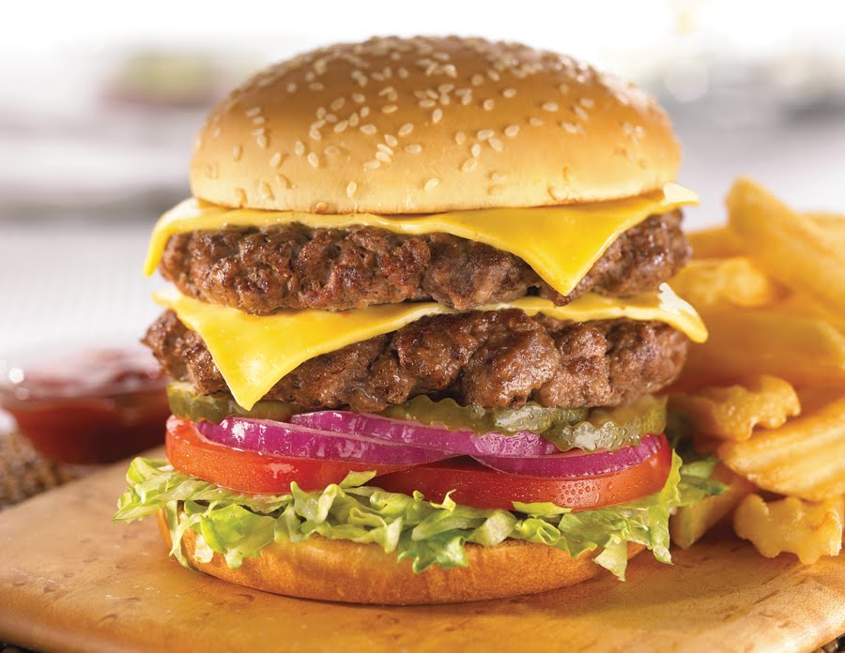

Sides:

* Café Nachos $6.95
  + Tortilla chips fried to order topped with sour cream, melted Colby Jack Cheese, Guacamole, Jalapenos, and Bacon
* Seasoned Fries $2.95
  + Thin crispy fries topped with spicy house seasoning
* Sweet potato fries $2.95
  + Hand Cut Fries served with chipotle ketchup

Deserts:

* Original Cheesecake $3.00
* Chocolate Cheesecake $2.50
* Strawberry Cheesecake $3.00

Drinks:

* Sodas $1.95/glass
  + Coke, Diet Coke, Sprite, Coke Zero, Orange Fanta
* Sweet Tea $1.95/glass
* Fresh Squeezed Lemonade $1.95/glass

